Onboarding of FBNQuest FirstNote on Digital Channels
Business Requirements Document (BRD)
Version 1.0

This document details the functional activities that the Product/Solution must be able to perform to meet the needs of the stakeholders. It will detail the exact inputs, behaviours and outputs expected. This document is important because it serves as a reference point for verification during testing of the final product. Examples include calculations, interpretation, processing, and formatting.

Document History
The following revision history reflects all changes made to this document:
Version | Date | Author(s) | Content/ Summary of Updates
V.01 | 17-11-2021 | Emmanuel Mgbodille | Initial Draft

Supporting Documents
Document Name | Author(s) | Location
Copy of PAYMENT TO PARTNERS(19170) | Andrew Adeoti | 

Document Approval
All parties involved acknowledge that they have read, understood, and agree with all the requirements as specified in this document.
Name | Role | Department | Signature and Date

Contents
Document History 2
Supporting Documents 2
Document Approval 2
1 Introduction 4
1.1 Objective 4
1.2 The Present “As-Is” Process Flow 5
A. Onboarding, Booking and Termination of FirstNote Investment “As-Is” Process Flow 5
1.3 The Envisioned New “To-Be” Process Flow 6
1.4. Business Requirements Overview 11
1.5 Scope and Limitations 11
1.6 Assumptions, Constraints and Dependencies 11
1.7 Risks 12
2 Business Requirements Specifications 12
2.1 Functional Requirements 15
2.2 Reporting Requirements 26
A. FirstNote Investment Status Report Requirements 26
2.2.1 Report Field Specifications 27
A. FirstNote Investment Status Report Field Specifications 27
2.3 Security & Control Requirements 28
2.4 Finance & Reconciliation Requirements 28
2.5 Non-Functional Requirements and Other Requirements 28
3 User Access Management for FirstNote Back Office 29
4 Change Management – Impact to the Bank 29
5 Appendixes- Snapshots of Report Formats 29
A. FirstNote Investment Status Report Format 29

Introduction

Objective
The objective of this project is to automate the manual investment process of FBNQuest FirstNote on all digital channels in First Bank. This document addresses all the business requirements necessary to deliver on the project.
FirstNotes is a hybrid investment and wealth solution for FBN customers, it will be accessed through our digital channels (FirstMobile, Lit & FirstOnline) and managed by FBNQuest Asset Management. The Bank is expected to share revenue with FBNQuest within a flexible regime guided by pre-determined factors.

This product will enable FirstBank retail customers who hitherto must visit a branch before they can do an indirect investment in an FBNQuest Asset Management product, to invest directly via Our digital channels (FirstMobile, Lit & FirstOnline) and avoid physical visits.
This automation initiative however, will be able to increase employees’ efficiency rate by 50%.

The Present “As-Is” Process Flow

A. Onboarding, Booking and Termination of FirstNote Investment “As-Is” Process Flow
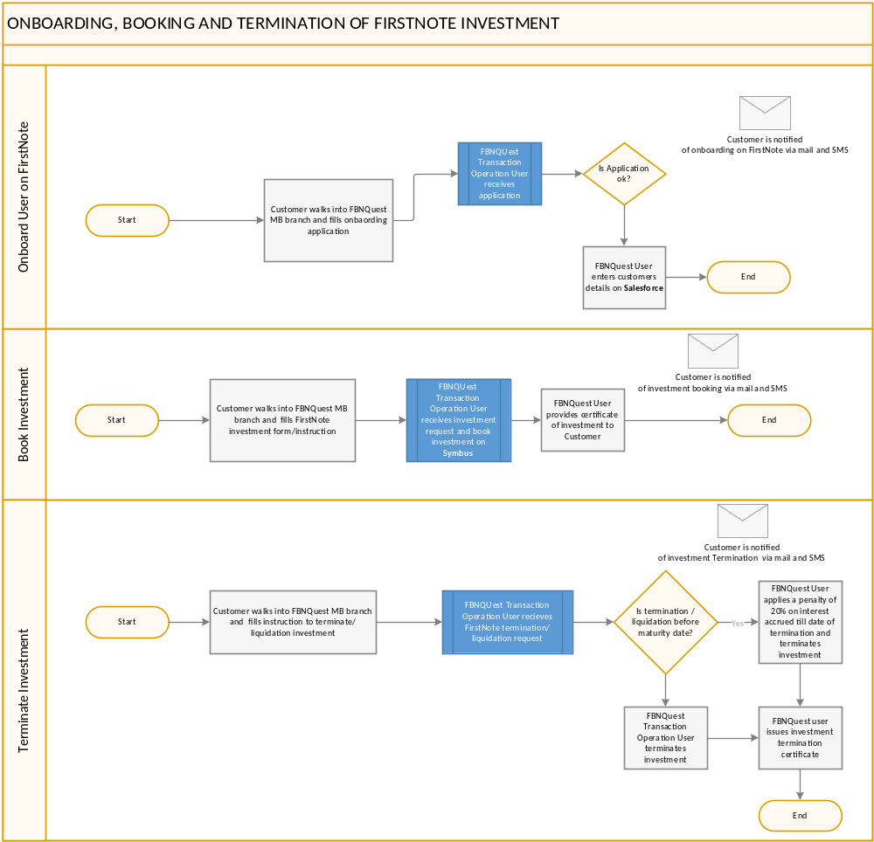
Fig 1.0 – process flow

The Envisioned New “To-Be” Process Flow

A. Onboarding of FBN Customer on FIRSTNOTE “To-Be” Process Flow
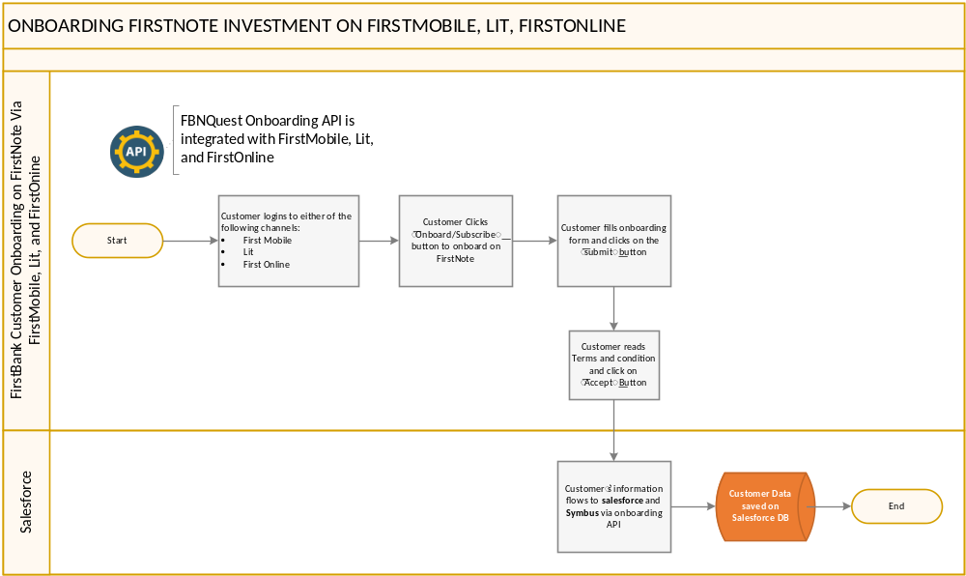
Fig 2.0 – process flow

C. Booking FirstNote “To-Be” Process Flow
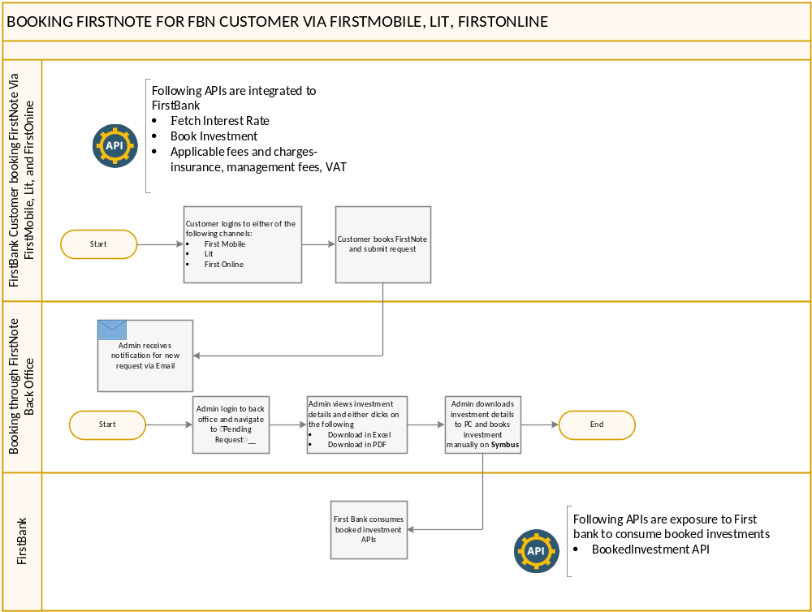
Fig 3.0 – process flow

E. Viewing FirstNote Investment Status – “To-Be” Process Flow
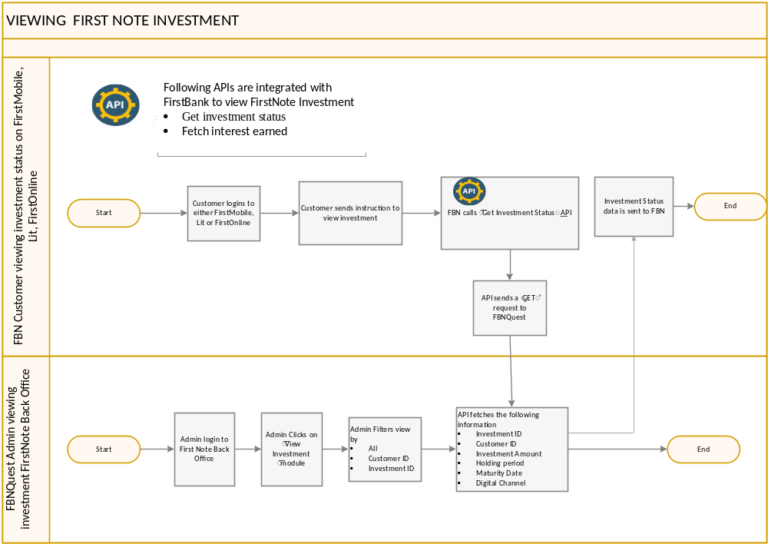
Fig 4.0 – process flow

E. Terminating FirstNote Investment – “To-Be” Process Flow
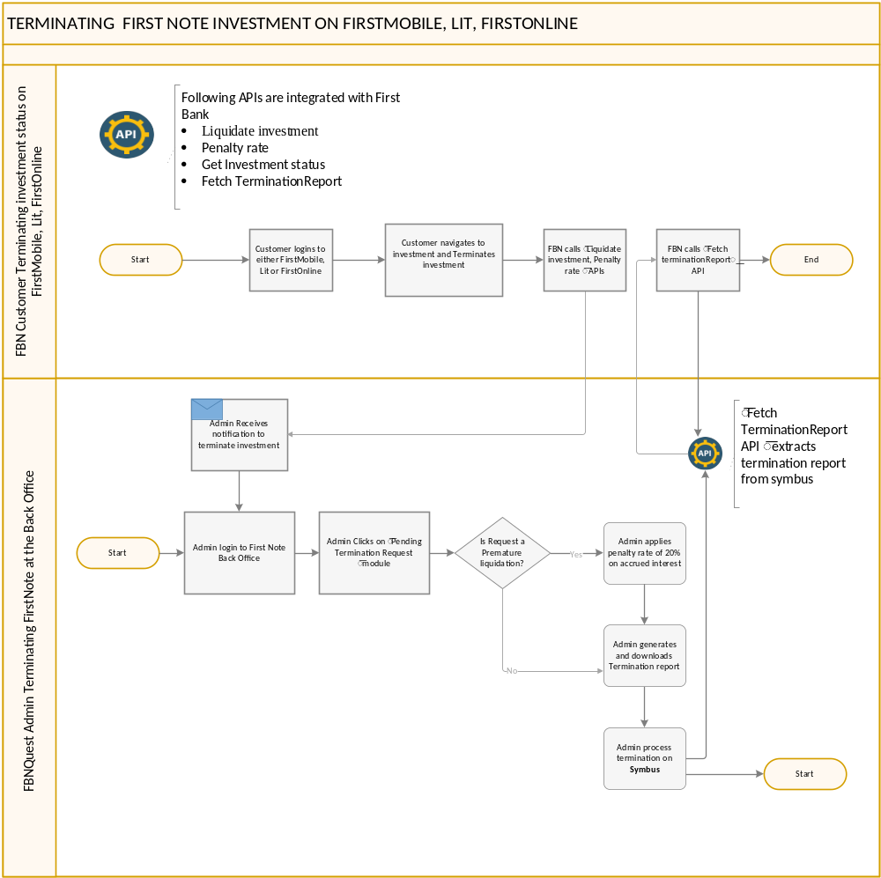
Fig 5 .0 – process flow

E. Generating FirstNote Investment Report – “To-Be” Process Flow
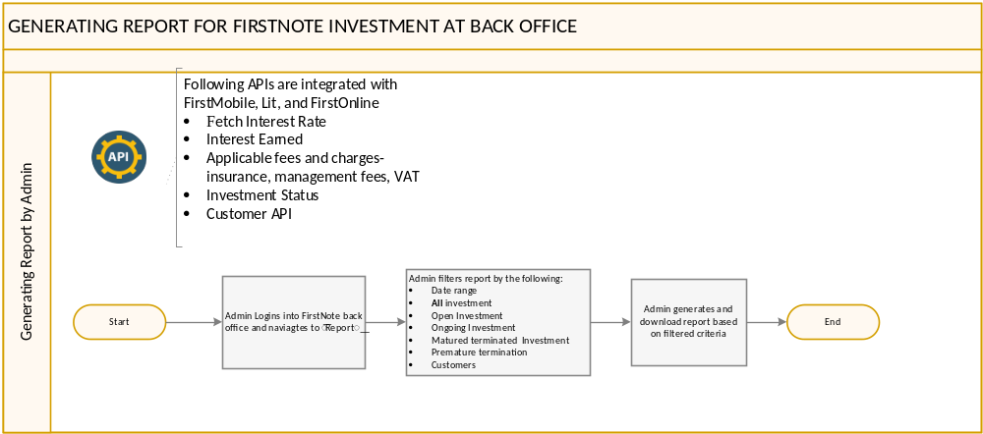
Fig 6 .0 – process flow

E. Settiing FirstNote Investment Parameters – “To-Be” Process Flow
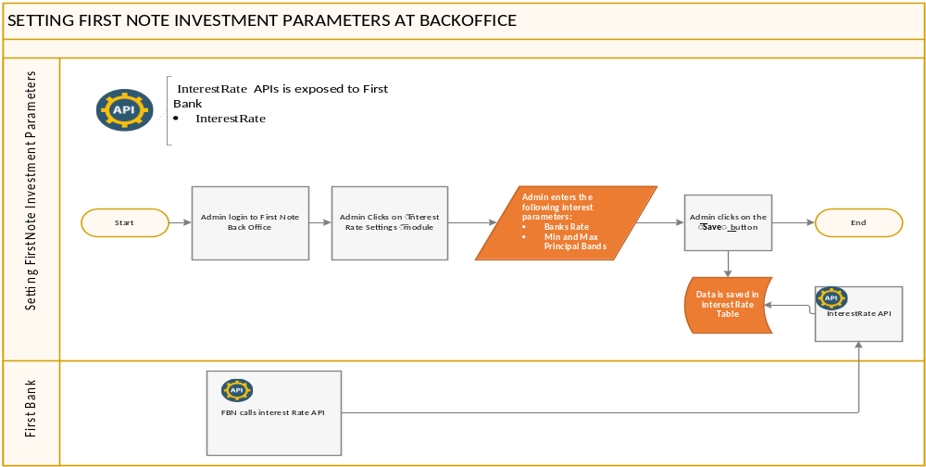

1.4. Business Requirements Overview
This document is intended to clearly describe the requirements for the automation FIrstNote investment subscription and termination between First Bank and FBNQuest. The business objectives for this automation include;
• To automate the manual process of onboarding, booking and termination of FirstNote between FirstBank customers and FBNquest.
• To increase employee’s general productivity and efficiency rate.
• To close the gap that exist in the current manual process

Scope and Limitations
In-Scope
The scope of work for the project shall include
- Integration of booking, viewing, onboarding, and terminating APIs with FirstMobile, Lit and FirstOnline.
- Automation of FirstNote onboarding, booking, and termination request
- Creation and generation of Investment reports
- Implementation of Admin Backoffice dashboard for investment settings and business intelligence.
Out-of-scope
All activities not in the confine of the in-scope boundary shall not be treated.

Assumptions, Constraints and Dependencies
Assumptions:
- FirstMobile, Lit, and FirstOnline applications exist
- FirstBank Customers already exist on digital channel(s)
- FirstBank Customers have tier 3 KYC requirement
Constraints:
- Not identified
Dependencies:
- FirstNote Report formats all investments
- Interest rates API
- Onboarding API
- Investment Status API
- Termination/Liquidation API
- Booking/Subscription API

Risks
RISKS | MITIGANTS
Implemented solution does not meet the requirements/objectives | To ensure all requirements are clearly defined and captured to satisfy business needs

Business Requirements Specifications
INPUT/TRIGGER | PROCESS | OUTPUT | NOTE
BR01: Ability to onboard FBN customer on FBNQuest for FirstNote Investment
Customer logins to any of the digital channel (FirstMobile, Lit, FirstOnline) and fills onboarding form | Onboarding API is triggered and integrates onboarding information to salesforce. | Customers recives a successful onboarding message to FirstNote
BR02: Ability of Push booked First Note investment to FBN
Customer logins to any of the digital channel (FirstMobile, Lit, FirstOnline) and enters the following to book FirstNote:  - Tenor  - Investment Amount | Book investment API captures investment parameters and parse to First Note Back Office. Back office Admin receives investment parameters and process FirstNote investment manually on Symbus. Booked Investments are passed to FBN via BookedInvestment API | FBN receives running/booked investments
BR03: Ability of FBNQuest User to Book FirstNote Investment for FBN Customers
FBNQuest User logins to FirstNote Back Office and enters the following to book FirstNote investment for FBN Customer:  - Customer CIF ID  - Tenor  - Investment Amount | Book investment API captures investment parameters and parse to First Note Back Office. Back office Admin receives investment parameters and process FirstNote investment manually on Symbus. Booked Investments are passed to FBN via BookedInvestment API | FBN receives running/booked investments
BR04: Ability of FBNQuest User to set First Note Investment Parameters at Back Office
Admin shall enter the following parameters to set FirstNote interest rate:  - Bank rate  - Principal bands value;  - Min value  - Max value | System stores investment parameter in an investment table for API calls | Investment parameters are stored in table.
BR05: Ability to integrate terminated FirstNote Investment between FBNQuest and First Bank
FBN customer makes a request to process Premature investment termination | System routes request to back office via the termination request API. FBNQuest Admin receives request, applies 20% penalty rate on accrued interest till date and process premature termination manually on Symbus. Premature Investments report Is shared with Firstbank via the PrematuredInvestment API | First Bank Receives report of Prematured Investment via API.
BR06: Ability of FirstNote Back office Admin to generate and download Investment reports
Admin selects the following parameters to generate investment reports:  - Date range  - Report Category:  - All  - Open investment  - Ongoing Investment  - Prematured investment  - Matured Investment  - customers | System generates report based on selected criteria. | Report is displayed and downloaded in either formats:  - PDF  - Excel | All APIs required to share reports with FirstBank are provided/integrated

Functional Requirements
S/N | Field Name | Field Description | Field Type | Field Logic
BR02 | Book Investment | User shall enter ther following fields  - Principal | Float | System captures data and store at Back Office.  Data is sent via API to First bank upon a call
BR02 | Book Investment | - Tenor | Integer
BR02 | Book Investment | - Rate | Float
BR04 | Interest Rate Setting | FBNQquest Admin shall enter the following fields:  - Bank Rate | Float | System captures data and store at Back Office.  Data is sent via API to First bank upon a call
BR04 | Interest Rate Setting | - Principal Amount Bands:  - Min Value  - Max Value | Long Integer
BR06 | Generate investment report | FBNQuest Admin can generate report by |  | System shall load selected report page with filtered criteria.  Report is shared with First Bank upon API call
BR06 | Generate investment report | - Date | Date
BR06 | Generate investment report | - Report Category:  - All  - Open investment  - Ongoing Investment  - Prematured investment  - Matured Investment  - customers | Text
BR01 | Onbaord Retail FBN Customer | User shall enter the following data to get onbaorded for FirstNote investment on Salesforce  - FirstBank Branch Name | Text | System captures data and store on salesforce.
BR01 | Onbaord Retail FBN Customer | - Initial Investment | Float | System captures data and store on salesforce.
BR01 | Onbaord Retail FBN Customer | - Title | Text | System captures data and store on salesforce.
BR01 | Onbaord Retail FBN Customer | - Gender  - Male  - Female | Checkbox | System captures data and store on salesforce.
BR01 | Onbaord Retail FBN Customer | - First Name | Text | System captures data and store on salesforce.
BR01 | Onbaord Retail FBN Customer | - Other Name | Text | System captures data and store on salesforce.
BR01 | Onbaord Retail FBN Customer | - Surname | Text | System captures data and store on salesforce.
BR01 | Onbaord Retail FBN Customer | - Resedential Address | String | System captures data and store on salesforce.
BR01 | Onbaord Retail FBN Customer | - Date of Birth | Date | System captures data and store on salesforce.
BR01 | Onbaord Retail FBN Customer | - Marital Status  - Single  - Married  - Divorced  - Widowed | Check box | System captures data and store on salesforce.
BR01 | Onbaord Retail FBN Customer | - Religion | Text | System captures data and store on salesforce.
BR01 | Onbaord Retail FBN Customer | - Email Address | Text | System captures data and store on salesforce.
BR01 | Onbaord Retail FBN Customer | - Mobile Phone | Number | System captures data and store on salesforce.
BR01 | Onbaord Retail FBN Customer | - State of Origin | Text | System captures data and store on salesforce.
BR01 | Onbaord Retail FBN Customer | - Nationality | Text | System captures data and store on salesforce.
BR01 | Onbaord Retail FBN Customer | - Do you have dual ctizizenship  - Yes  - No | Checkbox | System captures data and store on salesforce.
BR01 | Onbaord Retail FBN Customer | - Do you have immigrant status in or are you a resident of another country:  - Yes  - No | Checkbox | System captures data and store on salesforce.
BR01 | Onbaord Retail FBN Customer | - ID type:  - International Passport  - Drivers licence  - National ID Card  - Permanent Voters Card  - Others  - If other specify | Checkbox | System captures data and store on salesforce.
BR01 | Onbaord Retail FBN Customer | - ID Number | Number | System captures data and store on salesforce.
BR01 | Onbaord Retail FBN Customer | - ID issue Date | Date | System captures data and store on salesforce.
BR01 | Onbaord Retail FBN Customer | - ID Expiry Date | Date | System captures data and store on salesforce.
BR01 | Onbaord Retail FBN Customer | - Employment Status:  - Salaried Employement  - Self-Employed  - Retired  - Unemployed | Checkbox | System captures data and store on salesforce.
BR01 | Onbaord Retail FBN Customer | - Occupation | Text | System captures data and store on salesforce.
BR01 | Onbaord Retail FBN Customer | - Business/Employer Name | Text | System captures data and store on salesforce.
BR01 | Onbaord Retail FBN Customer | - Employer address | Text | System captures data and store on salesforce.
BR01 | Onbaord Retail FBN Customer | - Annual Salary/Expected annual income  - Less than 50,000 Naira  - 51,000-250,000  - 251,000-500,000  - 501,000-Less than 1Million  - 1Million-Less than 5Million  - 5Million- Less than 10Million  - 10Million-Less than 20Million  - Above 20Million | Checkbox | System captures data and store on salesforce.
BR01 | Onbaord Retail FBN Customer | - Source of Fund | Text | System captures data and store on salesforce.
BR01 | Onbaord Retail FBN Customer | - Next Of KIN Title | Text | System captures data and store on salesforce.
BR01 | Onbaord Retail FBN Customer | - Gender:  - Male  - Female | Checkbox | System captures data and store on salesforce.
BR01 | Onbaord Retail FBN Customer | - Date of Birth | Date | System captures data and store on salesforce.
BR01 | Onbaord Retail FBN Customer | - First Name | Text | System captures data and store on salesforce.
BR01 | Onbaord Retail FBN Customer | - Surname | Text | System captures data and store on salesforce.
BR01 | Onbaord Retail FBN Customer | - Mobile Phone number | Number | System captures data and store on salesforce.
BR01 | Onbaord Retail FBN Customer | BANK DETAILS |  | System captures data and store on salesforce.
BR01 | Onbaord Retail FBN Customer | - Account Name | Text | System captures data and store on salesforce.
BR01 | Onbaord Retail FBN Customer | - Type of Product | Text | System captures data and store on salesforce.
BR01 | Onbaord Retail FBN Customer | - Bank Name | Text | System captures data and store on salesforce.
BR01 | Onbaord Retail FBN Customer | - Branch Name | Text | System captures data and store on salesforce.
BR01 | Onbaord Retail FBN Customer | - Initial Investment Tenor:  - 30 days  - 60 days  - 90 days  - 180 days  - 365 days | Checkbox | System captures data and store on salesforce.
BR01 | Onbaord Retail FBN Customer | - Account Number | Number | System captures data and store on salesforce.
BR01 | Onbaord Retail FBN Customer | - Bank Verification Number(BVN) | Number | System captures data and store on salesforce.
BR01 | Onboard FBN Coporate customers | Coporate Users shall enter the following data to get onbaorded for FirstNote investment on Salesforce  - FirstBank Branch Name | Text | System captures data and store on salesforce.
BR01 | Onboard FBN Coporate customers | - Company/Business Name | Text | System captures data and store on salesforce.
BR01 | Onboard FBN Coporate customers | - Certificate of incorporation/Registration Number | Text | System captures data and store on salesforce.
BR01 | Onboard FBN Coporate customers | - Date of incorporation/Registration | Date | System captures data and store on salesforce.
BR01 | Onboard FBN Coporate customers | - Jurisdiction of incorporation /Registration | Text | System captures data and store on salesforce.
BR01 | Onboard FBN Coporate customers | - Business type/Nature | Text | System captures data and store on salesforce.
BR01 | Onboard FBN Coporate customers | - Sector/Industry | Text | System captures data and store on salesforce.
BR01 | Onboard FBN Coporate customers | - Corporate/Operating business address | Text | System captures data and store on salesforce.
BR01 | Onboard FBN Coporate customers | - Email address | Text | System captures data and store on salesforce.
BR01 | Onboard FBN Coporate customers | - Contact number 1 | Text | System captures data and store on salesforce.
BR01 | Onboard FBN Coporate customers | - Contact number 2 | Text | System captures data and store on salesforce.
BR01 | Onboard FBN Coporate customers | - Average annual Turnover:  - Less than 50M  - 50M-Less Than 500M  - 500M- Less than 5B  - Above 5B | Checkbox | System captures data and store on salesforce.
BR01 | Onboard FBN Coporate customers | - Tax identification number | Text | System captures data and store on salesforce.
BR01 | Onboard FBN Coporate customers | - Special control unit agency money Laundering (SCUML) Reg. No | AlphaNumeric | System captures data and store on salesforce.
BR01 | Onboard FBN Coporate customers | ACCOUNT SIGNATORY’S DETAILS FOR FIRST AND SECOND SIGNATORIES |  | System captures data and store on salesforce.
BR01 | Onboard FBN Coporate customers | - Title | Text | System captures data and store on salesforce.
BR01 | Onboard FBN Coporate customers | - Surname | Text | System captures data and store on salesforce.
BR01 | Onboard FBN Coporate customers | - Other name | Text | System captures data and store on salesforce.
BR01 | Onboard FBN Coporate customers | - First Name | Text | System captures data and store on salesforce.
BR01 | Onboard FBN Coporate customers | - Mother’s Maiden name | Text | System captures data and store on salesforce.
BR01 | Onboard FBN Coporate customers | - Date of Birth | Date | System captures data and store on salesforce.
BR01 | Onboard FBN Coporate customers | - Gender:  - Male  - Female | checkbox | System captures data and store on salesforce.
BR01 | Onboard FBN Coporate customers | - Marital Status:  - Single  - Married  - Divorced  - Widowed | Checkbox | System captures data and store on salesforce.
BR01 | Onboard FBN Coporate customers | - Nationality | Text | System captures data and store on salesforce.
BR01 | Onboard FBN Coporate customers | - Place of Birth | Text | System captures data and store on salesforce.
BR01 | Onboard FBN Coporate customers | - State of Origin | Text | System captures data and store on salesforce.
BR01 | Onboard FBN Coporate customers | - LGA of State pf Origin | Text | System captures data and store on salesforce.
BR01 | Onboard FBN Coporate customers | - Residency status:  - Permanent  - Temporary | Checkbox | System captures data and store on salesforce.
BR01 | Onboard FBN Coporate customers | - Resident Permit NO | Alphanumeric | System captures data and store on salesforce.
BR01 | Onboard FBN Coporate customers | - Permit issue Date | Date | System captures data and store on salesforce.
BR01 | Onboard FBN Coporate customers | - Permit Expiry date | Date | System captures data and store on salesforce.
BR01 | Onboard FBN Coporate customers | - Other country of tax residence | Text | System captures data and store on salesforce.
BR01 | Onboard FBN Coporate customers | - ID type:  - International Passport  - Drivers licence  - National ID Card  - Permanent Voters Card  - Others  If other specify | Checkbox | System captures data and store on salesforce.
BR01 | Onboard FBN Coporate customers | - ID number | Alphanumeric | System captures data and store on salesforce.
BR01 | Onboard FBN Coporate customers | - ID Issue date | Date | System captures data and store on salesforce.
BR01 | Onboard FBN Coporate customers | - ID Expiry date | Date | System captures data and store on salesforce.
BR01 | Onboard FBN Coporate customers | - Bank Verification No | Number | System captures data and store on salesforce.
BR01 | Onboard FBN Coporate customers | - Status/Job Title | Text | System captures data and store on salesforce.
BR01 | Onboard FBN Coporate customers | - Position/Office of the Officer | Text | System captures data and store on salesforce.
BR01 | Onboard FBN Coporate customers | - Residential Address | Text | System captures data and store on salesforce.
BR01 | Onboard FBN Coporate customers | - Mobile number | Number | System captures data and store on salesforce.
BR01 | Onboard FBN Coporate customers | - Mobile number 2 | Number | System captures data and store on salesforce.
BR01 | Onboard FBN Coporate customers | - Email Address | Var | System captures data and store on salesforce.
BR01 | Onboard FBN Coporate customers | - Class of signatory:  - A  - B  - C | Checkbox | System captures data and store on salesforce.
BR01 | Onboard FBN Coporate customers | - Date | Date | System captures data and store on salesforce.
BR01 | Onboard FBN Coporate customers | DETAILS OF DIRECTORS/TRUSTIES/PROMOTER/EXECUTORS/ADMNISTRATOR/PRINICIPAL OFFICERS |  | System captures data and store on salesforce.
BR01 | Onboard FBN Coporate customers | 54.Title | Text | System captures data and store on salesforce.
BR01 | Onboard FBN Coporate customers | 55.Surname | Text | System captures data and store on salesforce.
BR01 | Onboard FBN Coporate customers | 56.Other name | Text | System captures data and store on salesforce.
BR01 | Onboard FBN Coporate customers | 57.First Name | Text | System captures data and store on salesforce.
BR01 | Onboard FBN Coporate customers | 58.Mother’s Maiden name | Text | System captures data and store on salesforce.
BR01 | Onboard FBN Coporate customers | 59.Date of Birth | Date | System captures data and store on salesforce.
BR01 | Onboard FBN Coporate customers | 60. Gender:  - Male  - Female | checkbox | System captures data and store on salesforce.
BR01 | Onboard FBN Coporate customers | 61. Nationality | Text | System captures data and store on salesforce.
BR01 | Onboard FBN Coporate customers | 62.Place of Birth | Text | System captures data and store on salesforce.
BR01 | Onboard FBN Coporate customers | 63.Residency status:  - Permanent  - Temporary | Checkbox | System captures data and store on salesforce.
BR01 | Onboard FBN Coporate customers | 64. Resident Permit NO | Alphanumeric | System captures data and store on salesforce.
BR01 | Onboard FBN Coporate customers | 65.Permit issue Date | Date | System captures data and store on salesforce.
BR01 | Onboard FBN Coporate customers | 66.Permit Expiry date | Date | System captures data and store on salesforce.
BR01 | Onboard FBN Coporate customers | 67.Other country of tax residence:  - Yes  - No  - If yes, please specify (Text) | Checkbox | System captures data and store on salesforce.
BR01 | Onboard FBN Coporate customers | 68.ID type:  - International Passport  - Drivers licence  - National ID Card  - Permanent Voters Card  - Others  If other specify | Checkbox | System captures data and store on salesforce.
BR01 | Onboard FBN Coporate customers | 69.ID number | Alphanumeric | System captures data and store on salesforce.
BR01 | Onboard FBN Coporate customers | 70.ID Issue date | Date | System captures data and store on salesforce.
BR01 | Onboard FBN Coporate customers | 71.ID Expiry date | Date | System captures data and store on salesforce.
BR01 | Onboard FBN Coporate customers | 72.Bank Verification No | Number | System captures data and store on salesforce.
BR01 | Onboard FBN Coporate customers | 73.Status/Job Title | Text | System captures data and store on salesforce.
BR01 | Onboard FBN Coporate customers | 74.Position/Office of the Officer | Text | System captures data and store on salesforce.
BR01 | Onboard FBN Coporate customers | 75.Residential Address | Text | System captures data and store on salesforce.
BR01 | Onboard FBN Coporate customers | 76.Mobile number | Number | System captures data and store on salesforce.
BR01 | Onboard FBN Coporate customers | 77.Mobile number 2 | Number | System captures data and store on salesforce.
BR01 | Onboard FBN Coporate customers | 78.Email Address | Var | System captures data and store on salesforce.
BR01 | Onboard FBN Coporate customers | 79. Occupation | Checkbox | System captures data and store on salesforce.
BR01 | Onboard FBN Coporate customers | DETAILS OF NEXT OF KIN (SOLE PROPRIETOR) |  | System captures data and store on salesforce.
BR01 | Onboard FBN Coporate customers | 80. Title | Text | System captures data and store on salesforce.
BR01 | Onboard FBN Coporate customers | 81.Gender:  - Male  - Female | Checkbox | System captures data and store on salesforce.
BR01 | Onboard FBN Coporate customers | 82.Date of Birth | Date | System captures data and store on salesforce.
BR01 | Onboard FBN Coporate customers | 83.First Name | Text | System captures data and store on salesforce.
BR01 | Onboard FBN Coporate customers | 84.Surname | Text | System captures data and store on salesforce.
BR01 | Onboard FBN Coporate customers | 85.Other Name | Text | System captures data and store on salesforce.
BR01 | Onboard FBN Coporate customers | 86. Relationship | Text | System captures data and store on salesforce.
BR01 | Onboard FBN Coporate customers | 87.Email Address | Text | System captures data and store on salesforce.
BR01 | Onboard FBN Coporate customers | 88.Contact Address | Text | System captures data and store on salesforce.
BR01 | Onboard FBN Coporate customers | BANK DETAILS |  | System captures data and store on salesforce.
BR01 | Onboard FBN Coporate customers | 89. Account Name | Text | System captures data and store on salesforce.
BR01 | Onboard FBN Coporate customers | 90. Bank Name | Text | System captures data and store on salesforce.
BR01 | Onboard FBN Coporate customers | 91. Branch Name | Text | System captures data and store on salesforce.
BR01 | Onboard FBN Coporate customers | 92. Account Number | Number | System captures data and store on salesforce.
BR01 | Onboard FBN Coporate customers | Electronic Signature |  | System captures data and store on salesforce.
BR01 | Onboard FBN Coporate customers | Signature | e-signature | System captures data and store on salesforce.
BR01 | Onboard FBN Coporate customers | Date | Date | System captures data and store on salesforce.

Reporting Requirements

A. FirstNote Investment Status Report Requirements
REP01 | FirstNote Investment Status report
Unit Name | Transaction Operations
Name of Report | Symbus Investment Status Report
Report Description | A report showing status of investment booked with FBNQuest
Report Frequency | Daily
Logic | This report pulls records from the First Note investment database
Prompts | Fisrt Bank should also be able to pull this report via API for a specific customer. The report would be filtered by date.

Report Field Specifications

A. FirstNote Investment Status Report Field Specifications
COLUMN NAME | COLUMN DESCRIPTION | CURRENT DATA SOURCE/SYSTEM | FIELD CALCULATION
Customer Name | Customer Full name | Captured during customer registration/  salesforce database | N/A
Investment Type | Investment Type | Symbus | N/A
Account Type | Customer account type | Symbus | N/A
Cash Account | Customer cash account | Symbus | N/A
Investment Amount | Customer Principal Amount | Captured from First Bank Digital channels | N/A
Tenor | Customer investment tenor | Captured from First Bank Digital channels | N/A
Effective Date | Investment Value Date | Symbus | N/A
Maturity Date | Investment Maturity Date | Symbus | N/A
Interest Rate_AM | FBNQuest MB Interest Rate | Symbus | N/A
Accrued_Interest | Total interest accrued on investment | Symbus | =Branch_Accrued Interest + Customer_Accrued interest
Bank(Branch) Rate | First Bank’s interest rate | Symbus | N/A
Branch_Accrued Interest | First Bank accrued interest | Symbus | = investmen amount * Bank(branch) Rate
Customer Rate | Customer advised rate | Symbus | N/A
Customer_Accrued interest | Customer’s accrued interest | Symbus | = investmen amount * Customer Rate
Customer Total Paid Out Amount | Total amount paid out to customer | Symbus | = Investment Amount + Customer_Accrued interest

Security & Control Requirements
API Token will activated.

Finance & Reconciliation Requirements
Not Applicable

Non-Functional Requirements and Other Requirements
Not Applicable

User Access Management for FirstNote Back Office
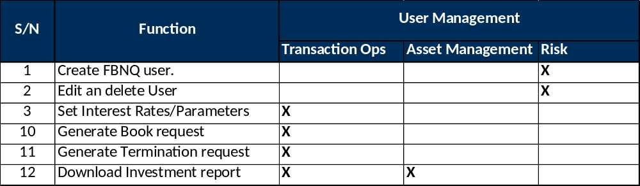

Change Management – Impact to the Bank
The solution poses no disruption to business processes. However, Users will be trained at UAT on the solution usage

Appendixes- Snapshots of Report Formats

A. FirstNote Investment Status Report Format
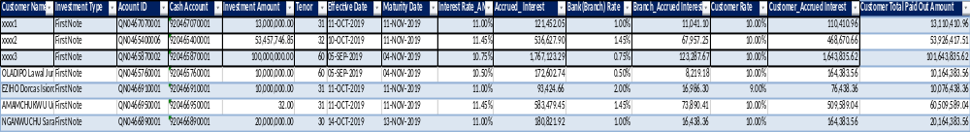

Glossary of Terms
- FBN: First Bank of Nigeria

